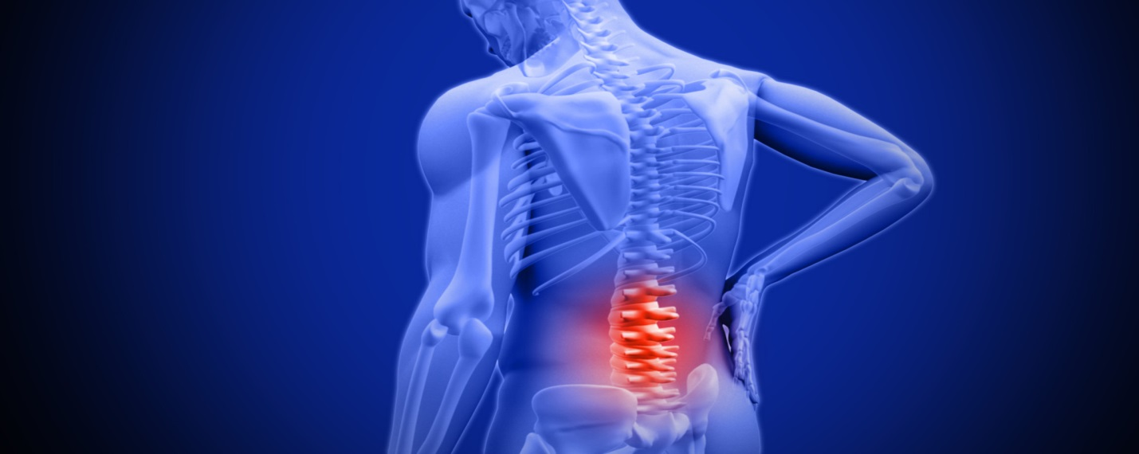
We will learn step-by-step how to work with:

Muscular-Skeletal Pains
Facial Pains
Scoliosis
Position of Mechanical Advantage to rest your back
Force of Habit
Inhibition of too much tension
Stress and Fight/Flight response
Directions Sending
Alexander’s Discoveries
Primary Control Mechanism

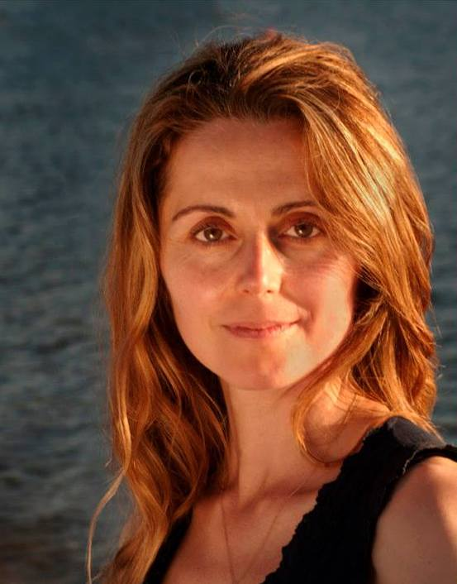
BACK PAIN AND SCOLIOSIS WITH YOGA AND ALEXANDER TECHNIQUE DISCOVERIES
Tuesdays, 5:45-6:45, $10. First class half price for GRY students. Ongoing.
Series begins: June 6 - July 11. No class on June 20th.
Please contact Alena or drop by on Tuesdays for the class.
778-885-6229, minova@shaw.ca
Learn to deactivate your unique deep patterns of tension and revive postural reflexes that support us in all of our activities.
Join us for this progressive and ongoing series of 5 classes. It is recommended to begin from Class One to optimize learning process. Yet, if you are curious, please don’t wait, pay us a visit and then you can attend the next series beginning with Class One again. Students will learn from every class.
We will be moving, resting back and learning. We will perform some unique exercises that are appropriate though for most people, with various levels of fitness. Although this course has been designed primarily for people with muscular skeletal pains, anybody can benefit from it. That is because the course teaches practical solutions to long standing issues of tension and their prevention
Teacher: Alena Minova is CanStat certified Alexander Technique teacher, a postural correction technique which is taught at major performance arts schools across the globe. It is an effective scientific method to work with excessive tension and pain. It is widely known among professional dancers, musicians and actors to cope and reverse repetitive strain injuries and performance anxiety— though there are benefits everybody can experience from applying Alexander skills in everyday life. There are currently 13 CanStat certified practitioners of Alexander Technique in Vancouver. Alena Minova is a certified Yoga Instructor. She is also certified to teach Yoga for Scoliosis (studied with Elise Browning Miller)

